Christensen, Per, Dr (mainly based on the writings of Roger Underwood)
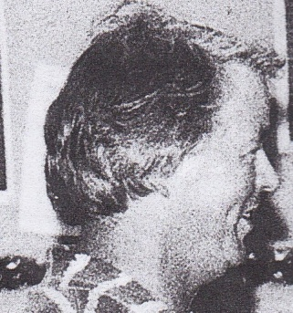

Per Christensen started his career as a forester trainee with the Kenya Forest Department. He completed a BSc (Hons) at Rhodes University in South Africa in 1967 and joined the Western Australian Forests Department in 1968 to work on karri silviculture and jarrah dieback. In the early 1970s initiated ecology research within the Forests Department, establishing long term fire effects studies on flora, fire ecology studies on fauna and starting biological survey work. His Ph.D thesis “ The biology of Bettongia penicillata Gray, 1837 and Macropus eugenii Desmarest 1804 in relation to fire” (Brush-tailed Bettong and the Tammar wallaby) was an extension of this work. Doctor of Philosophy, University of Western Australia, 1977.
During the 1980s and 1990s Dr Christensen became increasingly resolved with research administration, taking charge of research in the southern region and later in the Department of Conservation and Land Management (CALM) of all forest related research, and continuing his interest in ecology with fauna re-introduction work in the arid region in the Gibson desert and on the Peron peninsula. Dr Christensen was the first to discover that the fox was the main agent responsible for the decline and extinction of much of Australia’s native fauna and was responsible for having several extensive forest areas set aside as National Parks and reserves. He is the author and co-author of more than 50 scientific papers and chapters and the author of a book on the karri forest. Dr Christensen serves on several conservation related committees and consults on projects related to forest management and fauna conservation. Retired from CALM in 1996.

